Valerie Ellery
speaker and best-selling author of Creating Strategic Readers

Jennifer Serravallo speaker, consultant, and author of The Reading Strategies Book and The Literacy Techer’s Playbook
William Van Cleave - consultant and author of Writing Matters and Improving Phonemic Awareness Skills
Marilyn Pryle
middle/secondary ELA/ELL and author of 50 Common Core Reading Response Activities

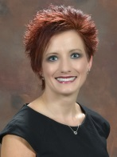
Rebecca Harper
Georgia Regents Regents University professor

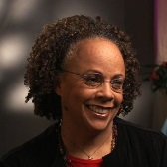
Jewel Parker Rhodes
Award-winning book author (Bayou Magic, Sugar) and creatie writing professor, Arizona State University

Anya Wallach
Social entrepreneur and creator of the Rondom Farms Kids’ Theater

Dana Sullivan
Writer and illustrator (Digger and Daisy)

William Teale
Professor, university scholar and member ILA Board of Directors

